**Previous Plus plan claims**

* 86156 Menchise-
  + CCOM table washed away during the hurricane
    - Replaced table
* 160216 Senft

* 146199 Fernandez
  + Glass broke on cocktail table
    - Replaced glass
* 130415 Stone
  + Fire damage to all items- $9308.92
    - * + Replaced all items

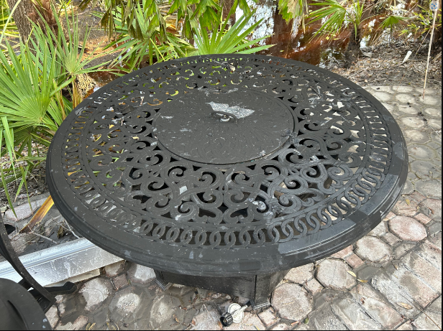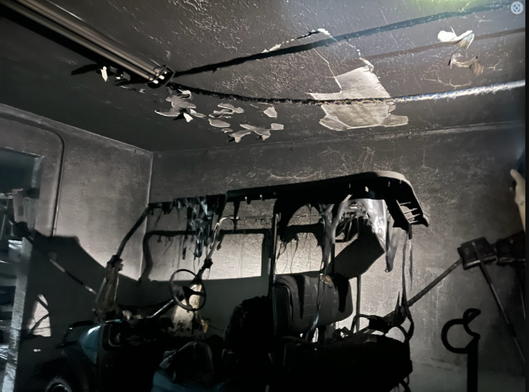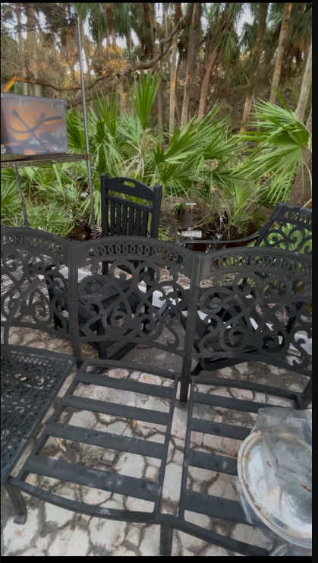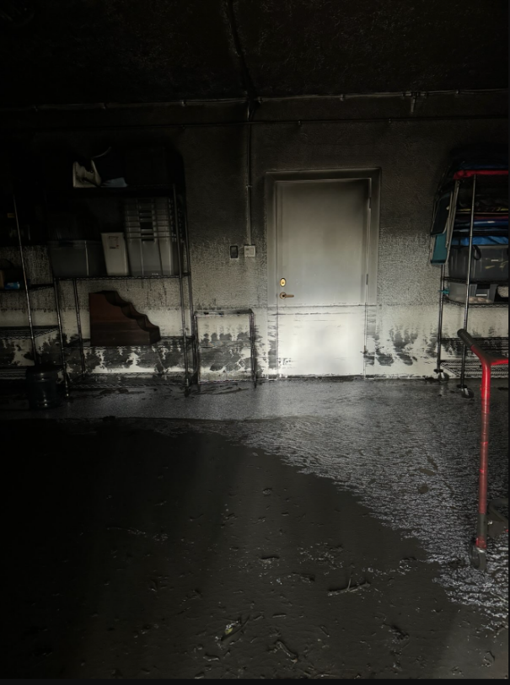

* 147461 Du Plessis
  + Dog chewed on the frames
    - Replaced frames

**

**Plus plan recap**

* Why add Protection Plan to your orders
  + Protects the customer
    - Gives piece of mind that the items are covered for the 1st 4 years of ownership
  + Covers accidents and natural disaster damage
    - No accumulation or neglect is covered
    - 25 claims for Oct -$14,924.39 due to hurricane damage
* How
  + Should be added to every order- per piece
    - Frame and cushion- 1 plan
    - Umbrella and base- 1 plan
    - Toss pillow- 1 plan per pillow
  + Explain previous plan usage and outcomes
    - See next page